**Food Delivery Web Application**

**Name: Ajinkya Subhash Kale**

**Project: Food Delivery Web Application**

**Technology: MERN**

**Date of Submission: 12-04-2025**

**Project Description:**

**Tomato** is a full-stack food delivery web application designed to connect customers with their favourite local restaurants and deliver meals right to their doorstep. This modern, responsive web app allows users to browse restaurant menus, place orders, track delivery status, and manage their profiles in real-time.

**Food Delivery Web Application** is a full-stack web-based platform that enables users to browse restaurants, view menus, place food orders, and get their meals delivered to their doorstep. This application is built using the **MERN stack** (MongoDB, Express.js, React.js, Node.js) to ensure high performance, a responsive user interface, and scalable backend services.

The system supports both **user** and **admin** roles. Users can register, log in, explore nearby restaurants, add food items to the cart, place orders, and track delivery status. Admins can manage restaurants, menus, and orders via a secure dashboard.

The application ensures smooth data flow between the client and server using RESTful APIs and maintains data integrity using MongoDB as the NoSQL database. JWT-based authentication is used to protect user sessions.

**Project Objectives**

• **Develop a User-Friendly Interface**

* Create an intuitive and responsive front-end using **React.js** to enhance user experience on both desktop and mobile devices.

• **Implement Secure User Authentication**

* Enable user registration, login, and role-based access (users and admins) using **JWT** and **bcrypt** for secure session handling and password encryption.

• **Enable Food Ordering Functionality**

* Allow users to browse restaurants and menus, add food items to the cart, place orders, and view order history.

• **Design an Admin Dashboard**

* Provide administrators with tools to manage restaurant listings, update menus, and monitor order status.

• **Real-Time Order Tracking**

* Implement a system for users to view the status of their orders (e.g., confirmed, preparing, out for delivery).

• **Build a Scalable and Robust Backend**

* Use **Node.js** and **Express.js** to create RESTful APIs that handle data processing and communication between the client and server.

• **Use MongoDB for Data Management**

* Store and manage user data, restaurant details, menu items, and order information using a flexible and scalable NoSQL database.

• **Ensure Code Modularity and Maintainability**

* Write clean, modular, and reusable code for long-term maintainability and scalability of the application.

• **Deploy the Application**

* Host the front-end and back-end on cloud platforms (e.g., **Vercel**, **Render**, **MongoDB Atlas**) for public access and demonstration.

• **Follow Best Practices in Web Development**

* Implement proper error handling, input validation, and follow security standards to ensure a safe and stable application.

**Tools and Technologies**

• Frontend: React.js, React Router, Axios, CSS (optional for styling)

• Backend: Node.js, Express.js

• Database: MongoDB (Mongoose for ORM)

• Authentication: JWT (JSON Web Tokens)

• APICommunication: RESTful APIs

• Deployment: (Optional) Render /(Frontend), MongoDB Atlas (Backend & DB)

**Features Implemented**

**User Module**

* User registration and login
* Profile management
* Secure authentication with JWT

**Restaurant & Menu**

* List of available restaurants
* Browse and search menus
* Restaurant & dish filtering by category/cuisine

**Cart & Order Management**

* Add to cart functionality
* Modify and remove items
* Checkout system
* Order confirmation

**Delivery Tracking**

* Track order status (Preparing, Out for Delivery, Delivered)
* Real-time updates (optional with socket.io or polling)

**Admin Dashboard**

* Manage restaurants and menus
* View and update order status
* User and delivery analytics

**Challenges and Solutions**

**1.Challenge: Managing User Authentication Securely**

* **Issue:** Protecting user data and managing different roles (user/admin) securely.
* **Solution:** Implemented **JWT (JSON Web Tokens)** for secure session management and **bcrypt** to hash passwords. Role-based access control was applied to restrict admin functionalities.

**2. Challenge: Designing a Responsive and Intuitive UI**

* **Issue:** Creating a seamless user experience across devices.
* **Solution:** Used **React.js** with responsive design frameworks like **Tailwind CSS** or **Bootstrap** to ensure mobile-friendly, user-centric interfaces.

**3. Challenge: Real-Time Order Tracking**

* **Issue:** Keeping users updated with their order status.
* **Solution:** Developed a dynamic order status feature using **status flags in MongoDB** and real-time updates via **polling** or **socket.io** for better user engagement.

**4. Challenge: Handling Data Consistency**

* **Issue:** Ensuring synchronization between user actions (like adding to cart) and backend data.
* **Solution:** Used **Mongoose** models and schema validation to maintain structured and consistent data in **MongoDB**. Implemented checks to avoid duplicate or invalid entries.

**5. Challenge: Managing Asynchronous Operations**

* **Issue:** Dealing with multiple asynchronous calls like API requests and database queries.
* **Solution:** Used **async/await** with proper error handling to manage API calls efficiently and avoid race conditions.

**6. Challenge: Secure Communication Between Frontend and Backend**

* **Issue:** Preventing unauthorized access to sensitive routes and APIs.
* **Solution:** Protected backend routes using **middleware** for JWT verification and used **CORS policies** to restrict access.

**7. Challenge: Deploying the Full-Stack Application**

* **Issue:** Deploying frontend, backend, and database so they communicate correctly in production.
* **Solution:** Deployed frontend with **Vercel**, backend with **Render**, and used **MongoDB Atlas** for a cloud-hosted database. Configured environment variables and routes accordingly.

**Future Enhancements**

* 1. **Online Payment Integration**
* Integrate secure payment gateways like **Stripe**, **Razorpay**, or **PayPal** to allow users to make online payments during checkout.

**2. Real-Time Order Updates**

* Implement **WebSocket** or **Socket.io** to provide real-time order status updates without needing to refresh the page.

**3. Ratings and Reviews System**

* Allow users to rate restaurants and leave reviews for dishes to improve user engagement and trust.

**4. Delivery Partner Module**

* Add a delivery agent dashboard where partners can log in, view assigned orders, and update delivery status.

**5. Push Notifications**

* Send browser or app notifications to users for order status, promotions, or delivery updates using tools like **Firebase Cloud Messaging (FCM)**.

**6. AI-Based Recommendations**

* Implement a recommendation engine to suggest dishes or restaurants based on user preferences, location, and order history.

**7. PWA Support (Progressive Web App)**

* Turn the web application into a **PWA** so users can install it on their devices and access it offline or in low-network conditions.

**8. Multi-Language Support**

* Add internationalization (i18n) to support multiple languages and improve accessibility for a wider audience.

**9. Coupon and Discount System**

* Create a promotional system where users can apply coupons or discount codes during checkout.

**10. Admin Analytics Dashboard**

* Provide advanced analytics for admins including sales reports, popular dishes, peak hours, and customer behavior insights.

.

**Conclusion**

The **Food Delivery Web Application** successfully demonstrates the implementation of a modern, full-stack solution that connects users with local restaurants through an intuitive and responsive interface. Built using the **MERN stack (MongoDB, Express.js, React.js, Node.js)**, the application handles core functionalities such as user authentication, menu browsing, order placement, and order tracking efficiently.

This project not only showcases technical proficiency in both frontend and backend development but also addresses real-world requirements like secure authentication, data management, and user interaction. With a scalable architecture and clear separation of concerns, the application lays a strong foundation for further enhancements such as real-time updates, payment integration, and analytics.

Overall, the project reflects a comprehensive understanding of full-stack development and provides a practical solution to the growing demand for convenient online food ordering systems.

**Output:**

**1.Front Section**

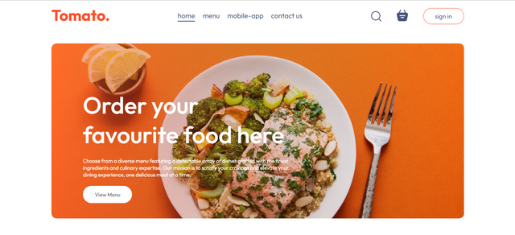

**2.** **Products Section**

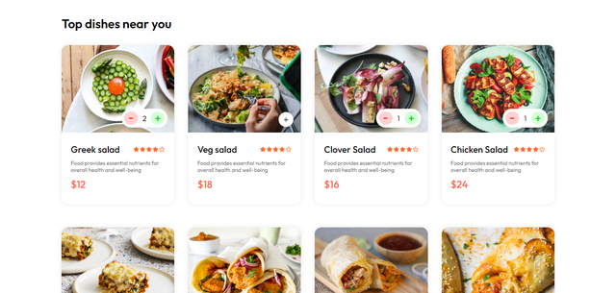

**3.Cart Page**

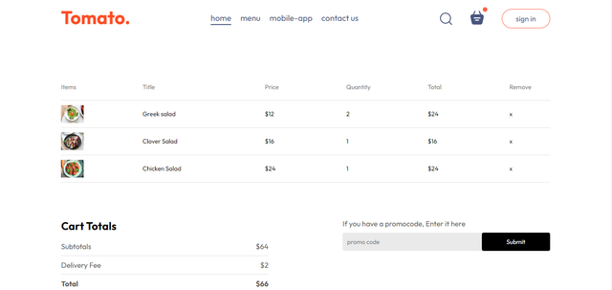

**4. Login Popup**

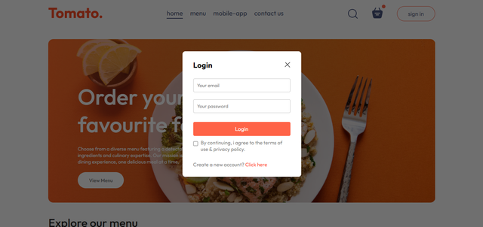

**5.Footer**

